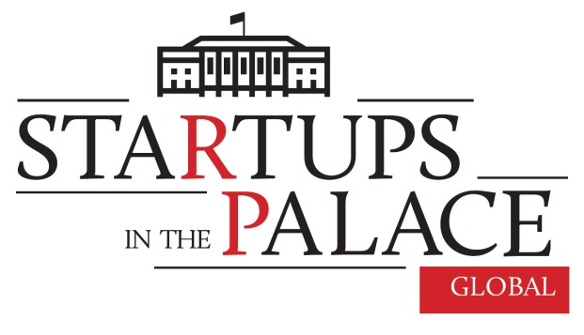

On October 4, 2017 (last Wednesday), the Presidential Palace hosted the finals of the 3rd edition of “Startups in the Palace”, attended by the President of the Republic of Poland Mr. Andrzej Duda. This time the leading theme of the event was: Polish startups going global.

The 3rd edition of “Startups in the Palace” was aimed at promoting Poland as an innovative economy, open to international cooperation, through presenting examples of Polish technological thought and investment environment in Poland. In this way, the Chancellery of the President of the Republic of Poland supports Polish startups in their global expansion and in establishing relations with investors, as well as with prospective clients.

Invitations to participate in the event were extended to carefully selected Polish startups developing groundbreaking technologies and ideas, who stand a real chance of entering global markets. Startups were recruited in cooperation with Foundation Startup Poland, the Polish Development Fund and representatives of the leading Polish startup events.

At the meeting, 10 Polish startups from the sectors of: energy, artificial intelligence, advanced material solutions, telemedicine, electro-mobility, modern education, blockchain and FinTech had the opportunity to make a pitch before the audience of the President of the Republic of Poland, Polish VC funds, innovative companies operating in Poland and international guests.

AISENS
The product developed by Aisens consists of sensors and a mobile application. The sensors enable an effective and safe rehabilitation anywhere, anytime. The solution targets such problems as the long waiting time for rehabilitation patients (6-12 months in Poland) or lack of the possibility of scaling in case of self-employed physiotherapists.

Born Electric
Born Electric is active in the field of design and construction of electric propulsion and steering systems. It offers a propulsion system with an alternative, innovative steering solution along with a multifunction battery. Plug&Drive is a ready-to-use propulsion system capable of replacing a combustion engine in light vehicles, machines or platforms. The system is already being tested in the environment of professional and leisure raced go-karts.

DrOmnibus
DrOmnibus creates applications which support education and therapy for children with special needs (Autism, Down syndrome). DrOmnibus applications consist of hundreds and thousands of tasks collected in the form of child-attractive games as well as a progress tracking system and a teacher`s/therapist`s organizer.

LGM S.A.
LGM S.A. is developing a power-steering technology which allows to produce more power from electricity generators. Thanks to removing the limitation from generators with permanent magnets, the start-up has been able to generate up to 5 times more power than the nominal value! Electric generators can produce 5 times more energy or be 5 times smaller, with the same power output guaranteed. As a result, energy can be cheaper and more readily available.

Quantum Lab
Polish technology of recognizing emotions based, among others, on facial expression. The Quantum Lab technology helps clients develop Customer Experience in diverse areas. The kind and level of emotions expressed by customers, users and viewers is measured in real time with regular web cameras and an original SI algorithm. It is the way to check the quality of customer service or the power of the marketing message. Globally there are 10 companies working on similar solutions, including Google and Microsoft.

Nanoceramics
Solutions are based on high-pressure sintering of ceramics – a method invented and developed by our team. Soft magnetic ceramics used for the production of coils are made of a mixture of iron and boron nitrite. The modified composition of the mixture allows to modulate resistance and the saturation level of the magnetic induction in ceramics produced. This allows for the application of such materials in a vast range of frequencies, with components being smaller, while transferring more energy at reduced production costs.

Synerise
Synerise is a Revenue Performance Management class platform, which increases the effectiveness of marketing actions through personalized communication with clients, campaigns using all kinds of channels (both: online and offline), marketing automation, as well as creation and development of loyalty programs. The system collects and analyses both online data (e-mail, push, SMS messaging campaigns), as well as the offline ones (WiFi, stationary shops). Thanks to the comprehensive nature of the platform, the data it provides show the current standing of the company, with a special focus on marketing and sales.

Telemedi.co
Telemedi.co offers telemedicine consultations via videoconferences/phone calls/chats. The client can get in touch with the doctor through the Internet site or using a mobile application. We cooperate with insurers who lower the cost of medical appointments thanks to teleconsultations. Patients do not need to visit the doctor or wait in the line. They can have a consultation every day, including holidays and weekends. Telemedico has also built telemedicine doctor`s surgeries – soundproof kiosks where doctors can be consulted. The kiosk houses telemedicine surgeries, where doctors can remotely check the results of patients` medical tests (blood pressure, ECG).

Unified API
UnifiedAPI specializes in the integration of financial institutions, such as banks or funds, via API, in accordance with the new directive PSD2, which shall enter into force in 2018. UnifiedAPI creates the market place for technology companies which are able to solve most complex problems faced by big financial companies.

Virtual Power Plant
Virtual Power Plant Sp. z o.o. (VPPlant) has developed intelligent tools which allow to adjust electricity and heat consumption in buildings with large total capacity to the changeable utilization patterns, while maintaining the level of comfort perceived by the users. As a result, participation in VPPlant programmes saves the costs of energy, and in the future it is bound to generate profits by providing services for the energy market by active energy users.

Each of the startups listed above was granted a special passport, awarded personally by the President of the Republic of Poland. The passport authorizes its holder to participate in one foreign economic mission.

