Decisions taken at the Extraordinary General Meeting of Shareholders of Sopharma AD, held on 23.02.2018

Sofia, Bulgaria, February 23, 2018 - Sopharma AD (3JR: “BSE-Sofia” AD, SPH: Warsaw Stock Exchange) notifies that on 23.02.2018 an Extraordinary general meeting of shareholders took place.
The General meeting of shareholders approved the decision for transformation of Sopharma AD, UIC: 831902088 by merging Unipharm AD, UIC: 831537465 into it. As a result of the merger, the entire property of Unipharm AD, UIC: 831537465 will be transferred to Sopharma AD, UIC: 831902088 under the conditions of general succession.

The General meeting of shareholders approved the Contract for transformation through merger of Unipharm AD into Sopharma AD, concluded on 14.09.2017, Additional Agreement No. 1 of 08.11.2017 to it (the "Contract for transformation through merger ").
The General meeting of shareholders approved the Report of the Board of Directors of Sopharma AD to the shareholders of the company regarding the transformation through merger of Unipharm AD into Sopharma AD.
The General meeting of shareholders approved the Auditor's Report under Art. 262m of the CA on the transformation through merger of Unipharm AD into Sopharma AD.

The General meeting of shareholders approved changes in the Company's Articles of Association which allows the payment of an interim dividend on the basis of a 6-month financial statement under the Public Offering of Securities Act.
The General Meeting of Shareholders, on the grounds of Art.187b of the Commercial Law and Art.111, para 5 of POSA, approved a resolution for the acquisition of own shares from the capital of the Company under the following conditions: up to 10% of the total number of shares issued by the company, but not more than 3% in each calendar year; term of the acquisition - no longer than 5 (five) years; minimum price for acquisition - not less than the nominal value per share of the company's capital; maximum price for acquisition - BGN 5.50 per share;
The minutes of the General Meeting of Shareholders of Sopharma AD, held on 23.02.2018, will be sent to you within the statutory term. All conversion documents are available as part of the materials of the extraordinary general meeting.

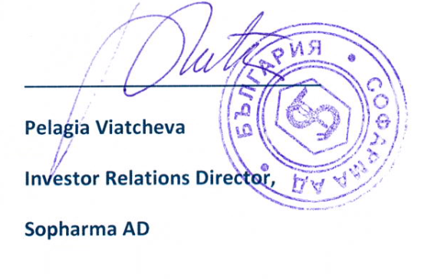

Information about the company
Sopharma AD
85 years tradition and modern approach – modern production, European quality standards, corporate social responsibility. Sopharma has an active and crucial role in raising standards of everyday life, in making people healthier, happier and safer. Sopharma AD continuously invests in technologies, innovation, research and science. We establish a constant and effective dialogue with all the actors in the pharmaceutical industry that contribute to the improvement of the health care system.
The company produces and markets medicinal substances and dosage forms; conducts research, engineering and implementation activities in the field of phytochemistry, chemistry and pharmaceuticals. Sopharma AD provides services related to production, as well as to ancillary and service activities.
The Company has a portfolio of more than 210 products: mainly generics and 15 original products, of which 12 products are phyto-based.
Sopharma Group
Sopharma Group is a vertically integrated healthcare business that operates in important sectors such as pharmaceuticals production, hospital supplies, pharmaceutical distribution (GDP standardized) and others. Sopharma and its production subsidiaries have 12 pharmaceutical plants in Bulgaria, complying with EU requirements – GMP and a factory in Ukraine certified by local authorities.

